Materials for Training Workshops on the Hotmaps Tool

Prepared by Marcus Hummel, Giulia Conforto, David Schmidinger, e-think

Reviewed by

Anders M. Odgaard, PlanEnergi  
Kinga Kovacs and Julien Jobert, Energy Cities  
Lukas Kranzl, TU Wien

Date 2019-08-24

Deliverable 6.4, 6.6 and 6.8 in course of the Hotmaps project

Project Information

08

Fall

|  |  |
| --- | --- |
| Project name | **Hotmaps** – Heating and Cooling Open Source Tool for Mapping and Planning of Energy Systems |
| Grant agreement number | 723677 |
| Project duration | 2016-2020 |
| Project coordinator | Lukas Kranzl  Technische Universität Wien (TU Wien), Institute of Energy Systems and Electrical Drives, Energy Economics Group (EEG)  Gusshausstrasse 25-29/370-3  A-1040 Wien / Vienna, Austria  Phone: +43 1 58801 370351  E-Mail: [kranzl@eeg.tuwien.ac.at](mailto:kranzl@eeg.tuwien.ac.at)  [**info@hotmaps-project.eu**](mailto:info@hotmaps-project.eu)  [www.eeg.tuwien.ac.at](http://www.eeg.tuwien.ac.at/)  [www.hotmaps-project.eu](http://www.hotmaps-project.eu) |
| Lead author of this report | Marcus Hummel  e-think  +43 670 7015799  hummel@e-think.ac.at  Anders Michael Odgaard  PlanEnergi  +45 2094 3525  amo@planenergi.dk |

Legal notice

The sole responsibility for the contents of this publication lies with the authors. It does not necessarily reflect the opinion of the European Union. Neither the EASME nor the European Commission is responsible for any use that may be made of the information contained therein.

All rights reserved; no part of this publication may be translated, reproduced, stored in a retrieval system, or transmitted in any form or by any means, electronic, mechanical, photocopying, recording or otherwise, without the written permission of the publisher. Many of the designations used by manufacturers and sellers to distinguish their products are claimed as trademarks. The quotation of those designations in whatever way does not imply the conclusion that the use of those designations is legal without the consent of the owner of the trademark.

The Hotmaps project

The EU-funded project Hotmaps aims at designing a toolbox to support public authorities, energy agencies and urban planners in strategic heating and cooling planning on local, regional and national levels, and in line with EU policies.

In addition to guidelines and handbooks on how to carry out strategic heating and cooling (H&C) planning, Hotmaps will provide the first H&C planning software that is

**User-driven**: developed in close collaboration with 7 European pilot areas

**Open source**: the developed tool and all related modules will run without requiring any other commercial tool or software. Use of and access to Source Code is subject to Open Source License.

**EU-28 compatible**: the tool will be applicable for cities in all 28 EU Member States

The consortium behind

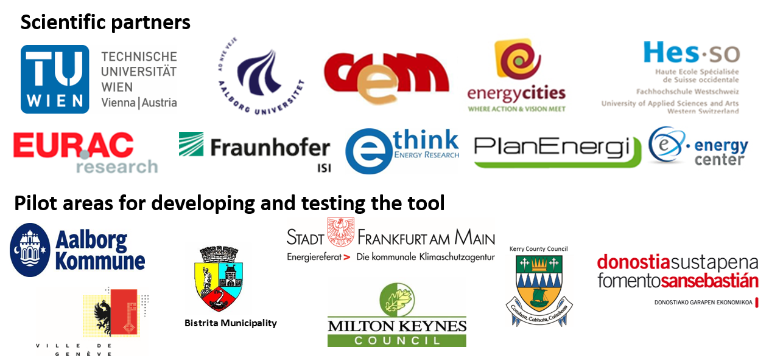

Executive Summary

This document presents the Hotmaps training materials and it provides guidelines and examples to assist the performance of further training workshops on the use of the Hotmaps tool, as well as the self-taught training.

This document covers the following expected deliverables in the course of the Hotmaps project:

* D6.4 Workshop education material for follower cities
* D6.6 Capacity building material for 2- days and 1⁄2-1 day  arrangements
* D6.8 First draft workshop education material  and capacity building  material (related to D6.4 and D6.6)

Please see the introduction for a detailed explanation of which part of the document correspond to each deliverable.

This document provides a list of all the available capacity building and educational materials produced in the course of the Hotmaps project, together with their respective use. Practical aspects of organizing and delivering the trainings are also explained, such as the adopted training structure, the selection of trainers, locations and timing, the promotion activities, the adoption of a registration platform and an e-learning platform.

Due to the COVID-19 global emergency, the on-site training workshops planned from March 2020 onwards had to be converted into online trainings. The trainings were adapted multiple times due both to the COVID-19 outbreak and to the experience and feedback gathered in the first two on-site trainings. This development process is explained by presenting both the original workshop draft and final agendas, as well as the online trainings agendas, together with the on-site training materials and those later used online.

Guidelines for a live presentation of the tool are shown, as that could be the introductory part of any workshop and online training. After that, all the sections of the trainings are explained in details and the training material used is illustrated, including the use of an e-learning platform, the exercises hand-outs and their relative solutions. Also the feedback collected is presented, providing both an overview of how the trainings were received, and how future trainings could build on this experience.

Finally, the legacy of the Hotmaps education activities is displayed, explaining how future training organizers can find and use all the materials mentioned in this document and kept available on the Hotmaps wiki.

Table of Contents

1 Introduction 11

Correlation to project deliverables 11

Use of the materials 12

COVID-19 outbreak and control measures 12

2 Before the training 14

Training structure 14

Trainers and locations 14

e-learning platform 14

Promotion and registration 15

Participants 16

Final pre-training email 16

3 Agenda 16

3.1 Draft Agenda of the workshop 16

3.2 Actual Agenda of the workshop 18

3.3 Agendas of the online training 18

4 Guide to a live demonstration of the tool 20

Map and layers visualization 20

Show indicators on NUTS 0 21

Show indicators at another level (NUTS 3) 22

Select a municipality and investigate RES potentials at LAU2 or hectare level 23

Download of layers 24

Upload of layers and own data 24

Show CM – Demand Projection 25

Show CM – Decentral Heating Supply 25

Show CM – Scale Heat and Cool Density Map 26

Show CM – District Heating supply dispatch 27

Show CM – District Heating potential: user defined thresholds 27

Show CM – District Heating potential: economic assessment 28

Additional and stand-alone Calculation modules 29

5 Training Material 29

5.1 On-site Training 30

Introductory webinar (3 hours, 2 - 3 weeks before the workshop): 30

Structure of the on-site training 30

Explanations, exercises, feedback collection, etc. 30

5.2 Online Training 30

Introductory webinar, one week before the intensive training (1 hour) 31

Introduction to the use of the tool, exercises 1 - 2 32

Wrap-up of exercises 1 - 2, introduction to exercises 3 and 4 33

Wrap-up of exercises 3 - 4, introduction to exercises 5 33

Closing and explanation of exercises 5, feedback questionnaire, certificates and final remarks 33

6 Feedback and lessons learned 34

6.1 On-site trainings 34

6.2 Online trainings 34

The tool 35

The documentation 37

The online training 38

Participants’ suggestions 38

The after-life of the Hotmaps-project 39

7 Legacy 40

8 Annex 41

List of Figures

Figure 1: The e-learning platform Google Classrom used for the Hotmaps Follower online training 14

Figure 2: Colour coding of the following training agendas 18

Figure 3: First Online training in English, April 27th - May 12th 2020 18

Figure 4: Online training in German, May 4th - 19th 2020 18

Figure 5: Second online training in English, stretched over three weeks, June 29th - July 17th 2020 19

Figure 6: Industrial sites and renewable energy potential from municipal solid waste at hectare level 20

Figure 7: Gross floor area total map for Austria at NUTS 0 level 21

Figure 8: Gross floor area total map for Spain at NUTS 0 level 21

Figure 9: Population, potential for industrial sites excess heat and forests residues at NUTS 3 level 22

Figure 10: Potential for industrial sites excess heat, wastewater treatment plants power and forests residues at hectare level 23

Figure 11: Calculation Module Demand Projection 24

Figure 12: Calculation Module Decentral Heating Supply 25

Figure 13: Scale Heat and Cool Density Map 25

Figure 14: Calculation Module District Heating Supply Dispatch 26

Figure 15: Calculation Module District Heating potential - user-defined thresholds 27

Figure 16: Calculation Module District Heating potential input parameters (left) and results (right) 27

Figure 17: Stand-alone CM Scenario Assessment 28

Figure 18: A view of the introductory quiz 30

Figure 19: Toolchain used from exercise 1 to progressively build the scenario assessed in exercise 5 31

Figure 20: A view of the Classwork section of the e-learning platform 33

Figure 21: Feedback on the userfriendliness of the tool 34

Figure 22: Feedback on the userfriendliness of the mapping functionalities and calculation modules 34

Figure 23: Feedback on what could be more user-friendly 35

Figure 24: Feedback on the usefulness of the calculcation modules 35

Figure 25: Feedback on the most liked part, and expected future use of the tool 36

Figure 26: Feedback on the training material 36

Figure 27: Feedback on the training quality and pace 36

Figure 28: Feedback on the training level and e-learning platform 37

Figure 29: Feedback on the different parts of the training and additional resources 37

Terms and Abbreviations

CDD Cooling Degree Day

CM Calculation Module

COVID-19 Coronavirus disease 2019, caused by severe acute respiratory syndrome coronavirus 2 (SARS‑CoV‑2)

DH District Heating

EASME Executive Agency for Small and Medium-sized Enterprises

EED EU Energy Efficiency Directive 2012

EEG Energy Economics Group, of the TU Wien

GWh Giga Watt hour

H&C Heating and Cooling

HDD Heating Degree Day

LAU2 Lower Local Administrative Level (formerly NUTS 5), a geocode standard for referencing the subdivisions of countries for statistical purposes corresponding to municipalities or equivalent units.

MWh Mega Watt hour

NUTS 0-3 Nomenclature of Territorial Units for Statistics, a geocode standard for referencing the subdivisions of countries for statistical purposes.

NUTS 0: countries

NUTS 1: groups of regions/states

NUTS 2: regions/states/provinces

NUTS 3: provinces/counties/prefectures/departments/districts

RES Renewable Energy Sources

SECAP Sustainable Energy and Climate Action Plan

TU Wien Vienna University of Technology (Technische Universität Wien)

Ideas for improvement on the way from D6.8 to D6.4 and D6.6

* Add other CMs in the chapter of the live presentation when they are available + also include import / export
* Split exercises for the parts as planned for the workshop:
* Mapping
* Planning
* Option A
* Option B
* …
* Include all links to the other materials when they are online
* Include a more detailed structure regarding the preparatory activity for setting up the workshops in chapter 2 (organise location and room, invite people, organise catering, organise example city representative, reserve a webinar slot, …)
* …

Also take into account the comments from Kinga and Julien from their review 🡪 they are contained in the version called Hotmaps_D6.8_DraftWSMaterials_v1_JJ_kk.docx

Comments from Kinga per Mail on this version (with my answers):

- From the experience we had in Aalborg, maybe it would be useful to have a live demo during the workshop and like that the 3 hours of exercise could be probably reduced. This is however foreseen during the preparatory webinar (?), but maybe if people don't attend it or don't watch it, it would be still useful to have during the workshop also. Is this on purpose to apply the ‘learning by doing” principle, letting the participants use the wiki?

maybe would be good to do the live demo twice, in the webinar and then at the workshop, maybe with different focus. good point

- For the part about the live demonstration, possibly use the “landscape” format of the pages, to have bigger screenshots, because we don’t see very well. -> ok

- There is only the content for the first half day, and not the full workshop, is this normal?

the content for the training on the calculation modules doesn't exist yet, also the calculation modules still do not exist. so yes, this is normal. We will add that after the next PM, where I guess we will have another training session as now in Aalborg and train the Hotmaps team on the calculation modules.

1. Introduction

This document is addressed both to future training hosts/organizers and future participants, wanting to understand and use the training material for a self-taught learning. In fact the present document is intended to:

* Illustrate how the training on-site workshops and online courses have been conceived, organized and carried out,
* Help future organisers and trainers to set up themselves training workshops and online courses on the Hotmaps tool,
* Support anyone interested in learning more on the Hotmaps tool functionalities and potential, to use the training material for a self-paced self-taught training and to acquire the understanding and skills to use the tool.

#### ***Correlation to project deliverables***

The Hotmaps project Grant Agreement foresees the following deliverables, in relation to the training and capacity building material:

* D6.4 Workshop education material for follower cities
* D6.6 Capacity building material for 2- days and 1⁄2-1 day  arrangements
* D6.8 First draft workshop education material  and capacity building  material (related to D6.4 and D6.6)

Originally, the follower cities 2 days workshop, the 2 days training addressing other areas and the ½-1 day training should have been organized separately. However, during the course of the project it became clear that this would have been highly ineffective, as the content of the follower cities workshop and that of the 2-days training would have been the same, and in addition, the introductory part of this training would have covered effectively the content of the ½ day training. Therefore, only one set of capacity building material was prepared for the on-site trainings, opening the follower cities workshop to other participants.

Subsequently, when the outbreak of the COVID-19 pandemic forced to a restructuring after just two workshops, all the 2 days and the ½ day trainings had to be provided virtually. The capacity building material was adapted to an e-learning format and the remaining online trainings were organized over a timespan of 2-3 weeks. The participants, who attended the full length of the online training, received a certificate equivalent to that released at the end of the 2-days training. Conversely, those participants who took part to the first introductory webinar, logged-in into the classroom, but did not complete the training, were considered as attending the equivalent of the ½-day training. Hence, D6.6 results by now providing also the content of D6.4.

D6.8 was added to allow examining a first draft of D6.4 and D6.6 halfway through the project, on how the trainings and the training material would have been organized. Hence, this document, fulfilling D6.6, covers the content expected to be provisionally provided in D6.8 too.

#### ***Use of the materials***

The following materials have been developed to assist the Hotmaps workshops and to learn to use the Hotmaps toolbox.

* This **Training Guideline** document providing
  + A guideline for workshop hosts / trainers
  + Exercises to be used in the workshops
  + Links to all other materials
* Various **Hotmaps video tutorials** showing the use of certain parts of the Hotmaps tool (<https://github.com/HotMaps/hotmaps_wiki/wiki>)
* The **Hotmaps Handbooks**:
  + Part I: Definition and experiences of strategic heat planning (www.hotmaps-project.eu/...)
  + Part II: Guidelines for developing national heating and cooling plans according to Article 14 of the EED (www.hotmaps-project.eu/...)
  + Part III: Applying the Hotmaps toolbox for heat planning (<https://github.com/HotMaps/hotmaps_wiki/wiki>)
* The **Hotmaps manual** documenting the functionalities of the toolbox and the calculation modules (<https://github.com/HotMaps/hotmaps_wiki/wiki>)
* The **Hotmaps brochure** highlighting the application of the tool (www.hotmaps-project.eu/...)
* Various **Hotmaps heating and cooling strategies for the pilot areas** in course of the project developed with the Hotmaps tool. These give an impression of the outcomes of the work with the Hotmaps toolbox ([www.hotmaps-project.eu/](http://www.hotmaps-project.eu/)...)
  + San Sebastián (link?)
  + Bistriţa (link?)
  + Frankfurt (link?)
  + Milton Keynes (link?)
  + Kerry County (link?)

#### ***COVID-19 outbreak and control measures***

The COVID-19 pandemic has caused many events around the world to be cancelled or postponed. Likewise, all the Hotmaps on-site trainings from March 2020 onward, originally planned to take place in-person, have been rescheduled and held virtually.

These are the trainings originally planned to be held in person:

* Bolzano (IT), December 9 th -10 th 2019 > Done
* Brussels (BE), February 19 th -20 th 2020 > Done
* Milton Keynes (UK), April 1st – 2nd 2020 > Cancelled due to Covid-19 pandemic.
* Frankfurt-am-Main (DE), May 5th – 6th 2020 > Cancelled due to Covid-19 pandemic.

These are the trainings that have been eventually held virtually as countermeasure:

* Online training in English, April 27th - May 12th 2020
* Online training in German, May 4th - 19th 2020
* Online training in English, stretched over three weeks, June 29th - July 17th 2020

Please see D6.5 and 6.7 for more details on the number and type of participants of each training, together with other details such as affiliation, country, gender, and progress achieved.

The conversion of trainings from on-site to online required a number of adjustments:

* Reorganizing the training agenda, from an intense 2-days training, to a two weeks duration, and eventually three weeks.
* Converting the material from a support to be used in person, with other participants and trainers available for an immediate feedback, to a distance-learning format, where participants could access all useful resources online, submit their assignments, have means to ask questions or signal issues
* Reorganizing the training team, making sure to have at least a trainer every 15 participants, available for the whole duration of the training
* Identifying and adopting a webinar platform (Teams), where participants could connect to attend live webinars and support groups
* Identifying and adopting an e-learning platform (Google Classroom), where participants could access anytime all the useful training material, receive new assignments, receive guidance, submit their work and provide feedback

1. Before the training

#### ***Training structure***

The training has been set up to combine:

* A presentation of the Hotmaps project.
* A virtual tour of the Hotmaps tool.
* Practical and written exercises, to be performed by the participants based on spreadsheets and explanatory documents.
* Support, Discussion and Feedback sessions.

In the online version of the training, all activities originally planned in person, were replaced by a mix of:

* Live sessions / webinars (introduction at the beginning and wrap up at the end)
* Videos explaining the data, the platform and the exercises
* Online support sessions with a trainer (optional)

The training material has been structured, so that participants are guided through the Hotmaps tool-chain, setting up heating (and cooling) scenarios for a sample city in five steps:

* Exercise 1: Mapping of heat demand and resource potentials
* Exercise 2: Calculation of decentral heat supply costs
* Exercise 3: Calculation of district heating supply costs
* Exercise 4: Calculation of district heating distribution costs
* Exercise 5: Setting up of consistent scenarios for the region

#### ***Trainers and locations***

The trainers were selected based on their familiarity with the tool, their availability to take part to the trainings, and their language skills for the training held in German.

The locations of the four on-site trainings have been selected because of the detected presence of a substantial number of heating and cooling professionals, interested in learning how to use the Hotmaps tool. This was either reported by some of the project partners or more often by the pilot city administration itself.

For the online trainings, no location was required, but the creation of webinars rooms and link, as well as the adaptation of the training material and the set-up of the e-learning platform.

#### ***e-learning platform***

The e-learning platform Google Classroom has been chosen for its accessibility and user friendliness. In fact, it is a free platform, accessible with any private Google account, and quite straightforward to use for both trainers and participants. It has a wall dedicated to general communications, a classwork section that can be organized per themes and allows attachments, links, shared documents, and other items such as online forms that we used for a multiple answer test and the feedback questionnaire.

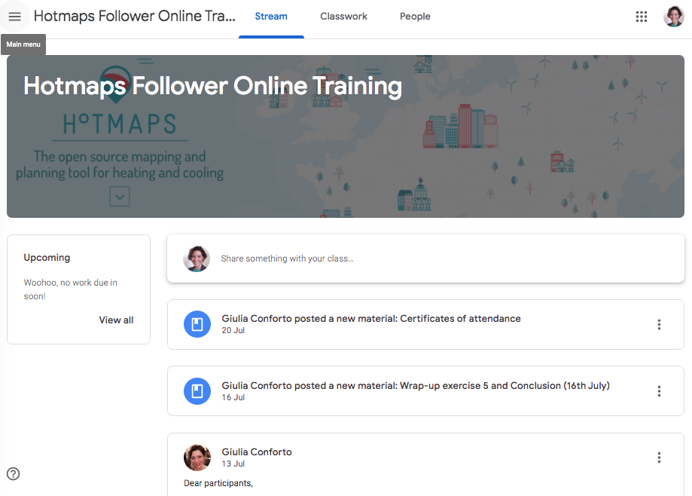

Figure 1: The e-learning platform Google Classrom used for the Hotmaps Follower online training

To give you an idea of how the e-learning environment was organized for the Hotmaps online trainings, we prepared two sample classrooms, one in English and one in German, which can be accessed anytime as participant with the following codes and link:

English access code: **ealdt6b**

German access code: **tzfxr5w**

[Link to Google Classroom](https://classroom.google.com/)

#### ***Promotion and registration***

We have published every training event, both on-site and online, on the event management and ticketing website “Eventbrite”, allowing for free registration, to be able to size adequately the training offer and collect participants contact details.

Trainings have been promoted through multiple channels (Hotmaps project website, partner organizations, category associations, etc.). Several participants have been directly invited to join the trainings, while other have spontaneously decided to join, following the promotion activities.

#### ***Participants***

Targeted participants belonged to the following categories coming mostly from EU and neighboring countries:

* Consultancy companies
* Local or regional energy agencies
* Local or regional public authorities
* Research and academics
* Business
* NGOs / Associations
* Other

Please see D6.5 and 6.7 for more details on the proportion between categories concerning the participants attending each training.

#### ***Final pre-training email***

Before the beginning of each training, the following steps had to be completed:

* Define and organise timing, trainers, location, room, and catering (on-site)
* Define and organise timing, trainers, webinar slots, e-learning platform
* Finalize training material
* Invite participants, promote trainings, set up registration platform

All registered participants have been contacted by email before the beginning of the training, receiving the final agenda before the training, while the participants to the online training also received and some introductory material and details to access the webinar and the e-learning platform. The trainings have been structured to be accessible to anyone without any prior preparation. Nonetheless, please note that due to the technical and very sector-specific nature of the Hotmaps tool, all trainings have been addressed to heating and cooling planning professionals. For those participants lacking the theoretical preparation around heating and cooling planning, we recommended to consult beforehand the Hotmaps Handbooks and acquire the adequate theoretical understanding.

1. Agenda
   1. Draft Agenda of the workshop

|  |  |  |
| --- | --- | --- |
| **Day I** | | |
| **Start** | **Content** | **Comment** |
| 12:00-12:30 | Welcome and introduction   * Short presentation of the participants and the respective situation * Overview of the workshop agenda |  |
| 12:30-13:30 | Presentation of example city (e.g. nearest pilot area)   * Current situation and political targets * Available data and comparison with default data * Scenarios calculated with the Hotmaps tool * Insights in the strategy formulation and outcomes | E.g. a delegate of the nearest Hotmaps pilot area |
| 14:30-17:30 | Exercises and group work I (focus **mapping** – data integration):   * Derive demand and RES potential data for the participants regions from the default data set * Create user account and upload individual data for the participants regions (heat demand density, RES potentials, etc.) * Mapping of data, comparing default and individual data * Derive defined indicators and maps for the participants regions * Export / Save the uploaded data | Several Hotmaps trainers on-site to assist the participants |
| 17:30-18:00 | Feedback from participants on:   * Data quality of default data for their region * Available and missing functionalities for the mapping process * Expectations for day II |  |
| 20:00 | Joint dinner |  |

|  |  |  |
| --- | --- | --- |
| **Day II** | | |
| **Start** | **Content** | **Comment** |
| 09:00-12:00 | Exercises and group work II (**planning I**):   * Short introduction to possible planning topics (Options A – E below) * Split into 2 – 3 groups for selected topics * In each group then   + Demonstration of main functionalities of the necessary modules   + Performance of predefined exercises by the participants using either own or default data   Examples for options:   * Option A: integration of renewables * Option B: excess heat integration * Option C: district heating expansion * Option D: decentralised heating assessment * Option E: renovation strategies | Several Hotmaps trainers on-site to assist the participants, one trainer per topic at least |
| 12:00-13:00 | Lunch |  |
| 13:00-15:30 | Exercises and group work III (**planning II**):   * Split into 2 – 3 groups for selected topics * In each group then   + Demonstration of main functionalities of the necessary modules   + Performance of predefined exercises by the participants using either own or default data * Participants select a different group than in the morning (in planning I) | Several Hotmaps trainers on-site to assist the participants, one trainer per topic at least |
| 15:30-16:30 | Feedback from participants on:   * Available and missing functionalities for the planning process * Presentation of “lessons learned” and conclusions for heating and cooling strategy development * Filling in an evaluation form for the training |  |
| 16:30-17:00 | Closing remarks  Handover of certificates |  |

* 1. Actual Agenda of the workshop
  2. Agendas of the online training

Here are reported the final agendas of the three online training. After the first two trainings were carried out, additional participants contacted the Hotmaps training team, asking for an additional training, if possible. This was organized on a longer timespan, as explicitly requested.

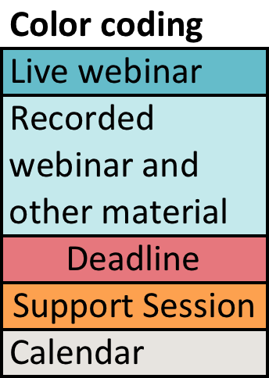

Figure : Colour coding of the following training agendas

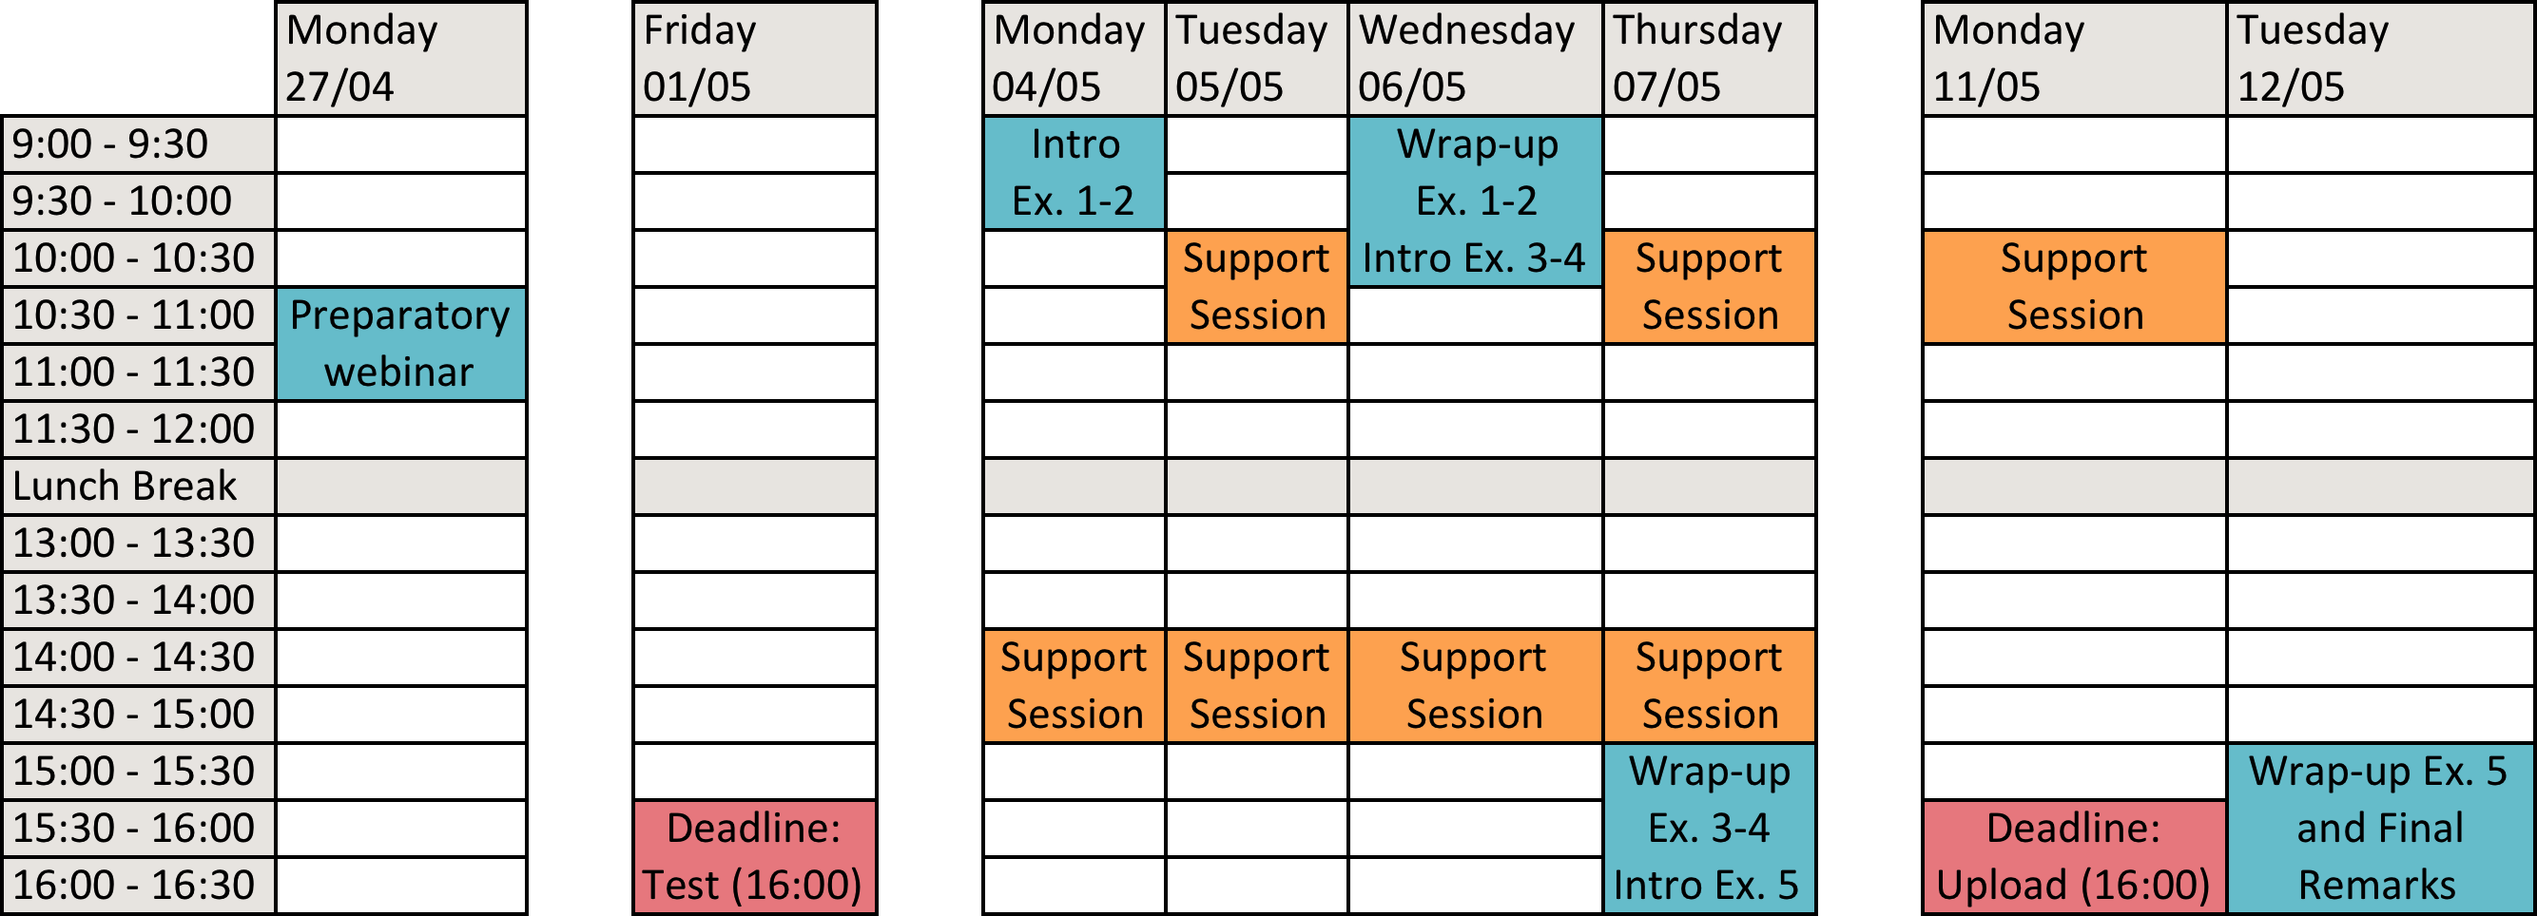

Figure : First Online training in English, April 27th - May 12th 2020

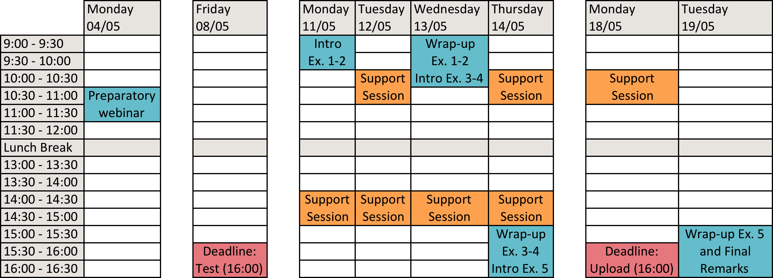

Figure : Online training in German, May 4th - 19th 2020

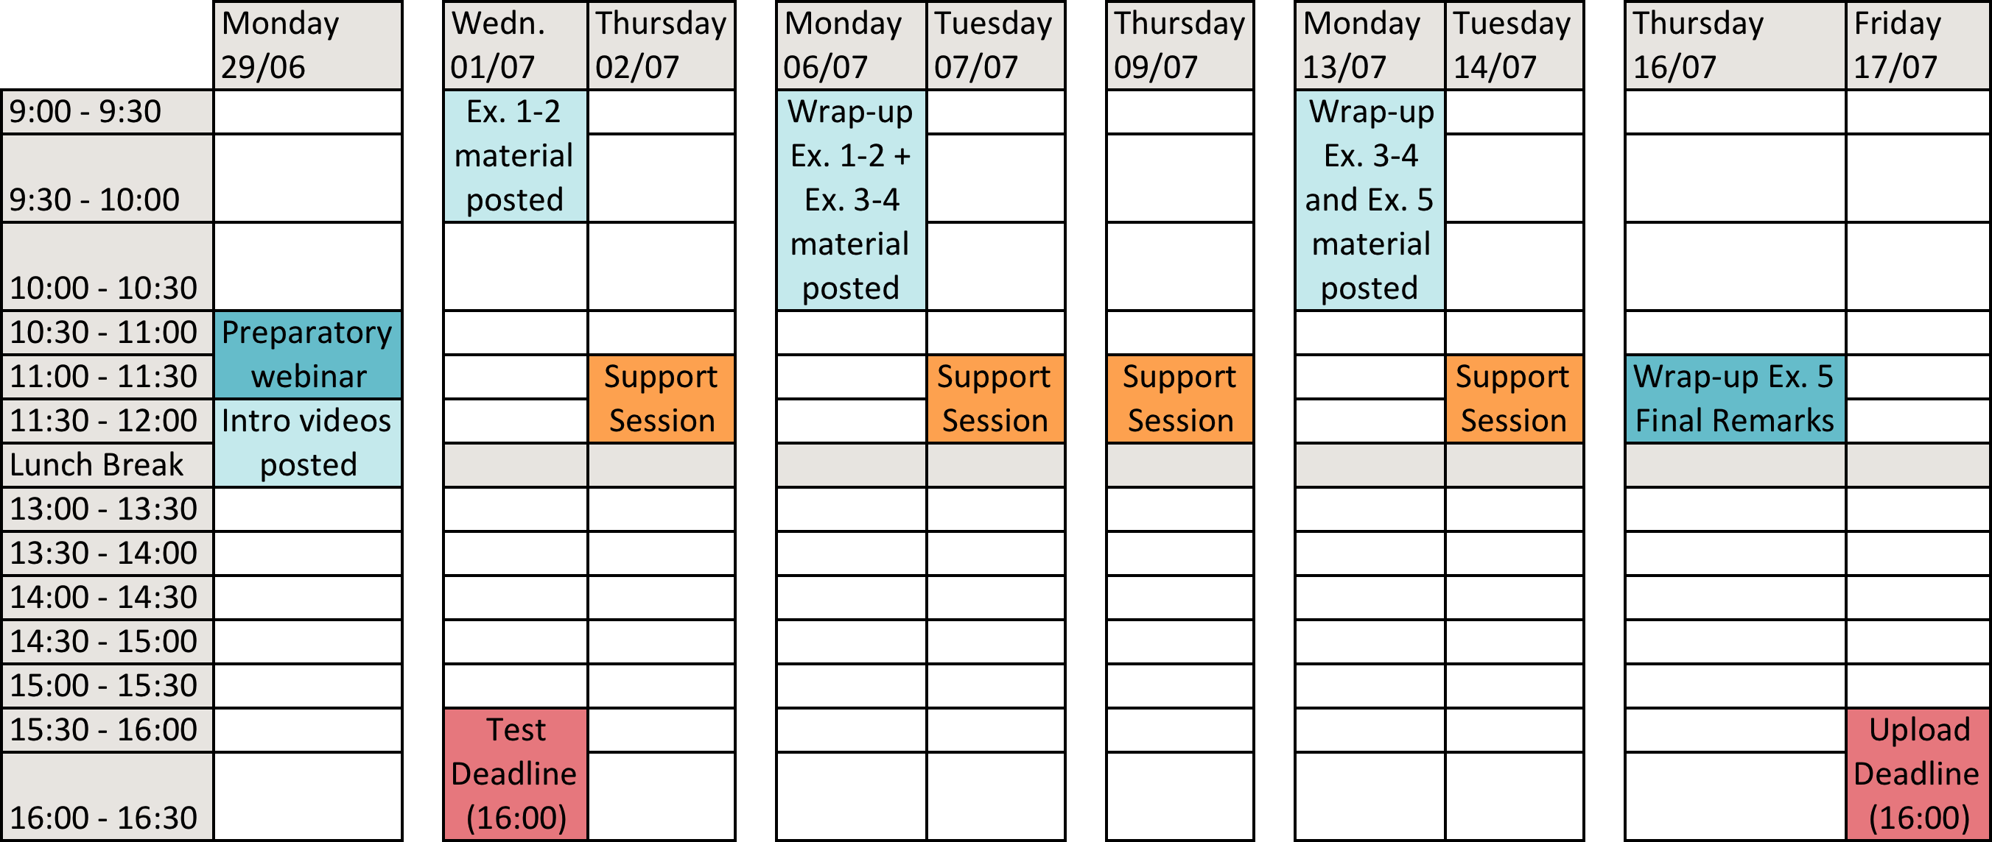

Figure : Second online training in English, stretched over three weeks, June 29th - July 17th 2020

1. Guide to a live demonstration of the tool

A good way to introduce the Hotmaps toolbox is by showing its functionalities directly on the tool website. Here we suggest ideas for an introductory live presentation of the tool.

#### ***Map and layers visualization***

The tool opens on a map. A good starting point is opening the layers menu from the top bar, and selecting one or more layers of the following from the menu that opens on the left:

* Heat
* Climate
* Industry
* Potentials - Geothermal
* Nuts data

Unclicking each layer after showing it one by one will avoid it to overlap with the next one. You may find useful to preload the layers before the demo, and to not scroll around, keeping the zoom level and place constant to show how the same map gets populated with different layers.

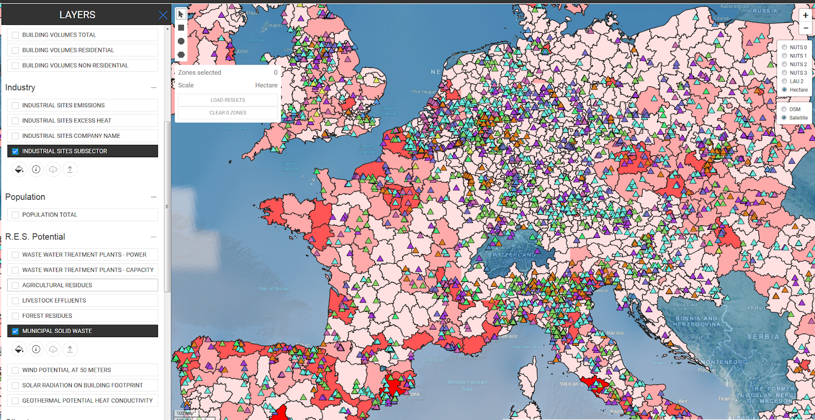

Figure : Industrial sites and renewable energy potential from municipal solid waste at hectare level

#### ***Show indicators on NUTS 0***

As the highest level of granularity of the data is NUTS 0 (country level), we suggest showing one or more of the following indicators at this level:

* Heat demand
* Cooling demand
* Population
* Heating degree days (HDD), cooling degree days (CDD)
* Industry, some potentials

This can be a good occasion to explain how these indicators are intended, and maybe to show a comparison with a second country. The results are shown on the right side.

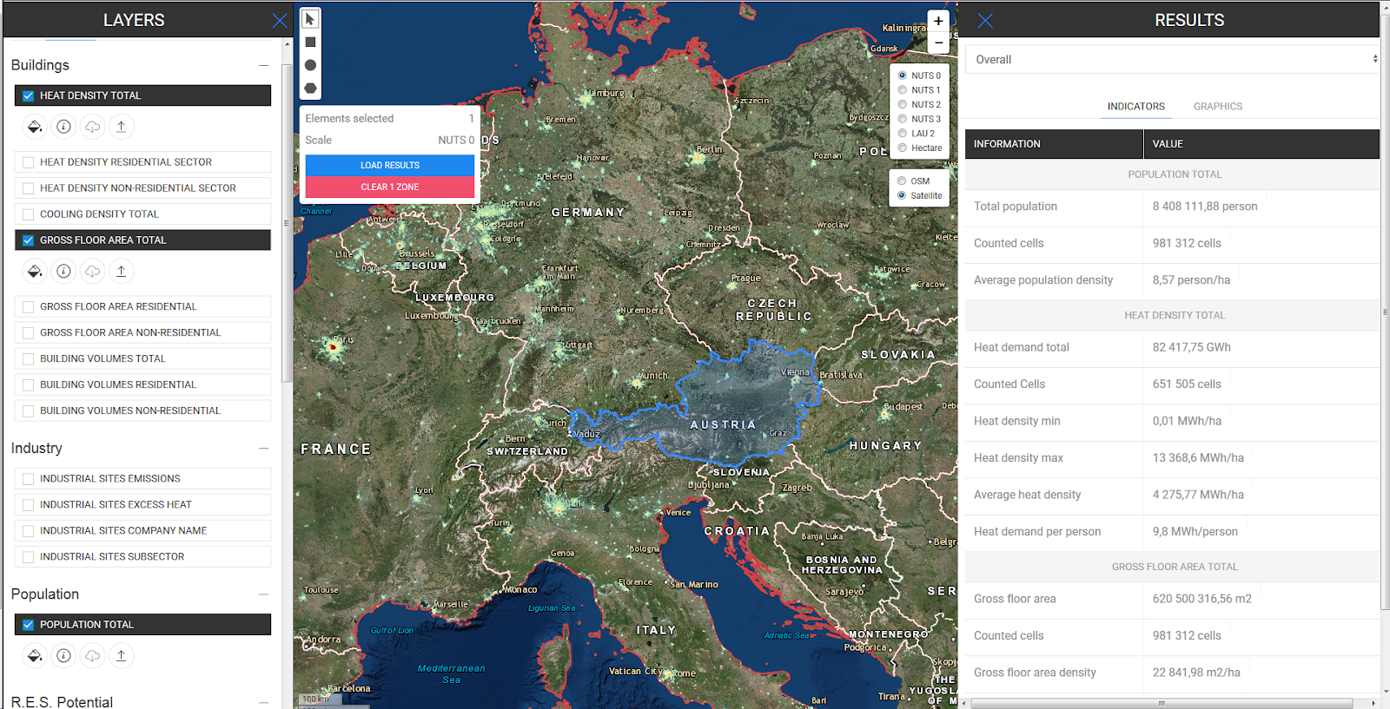

Figure : Gross floor area total map for Austria at NUTS 0 level

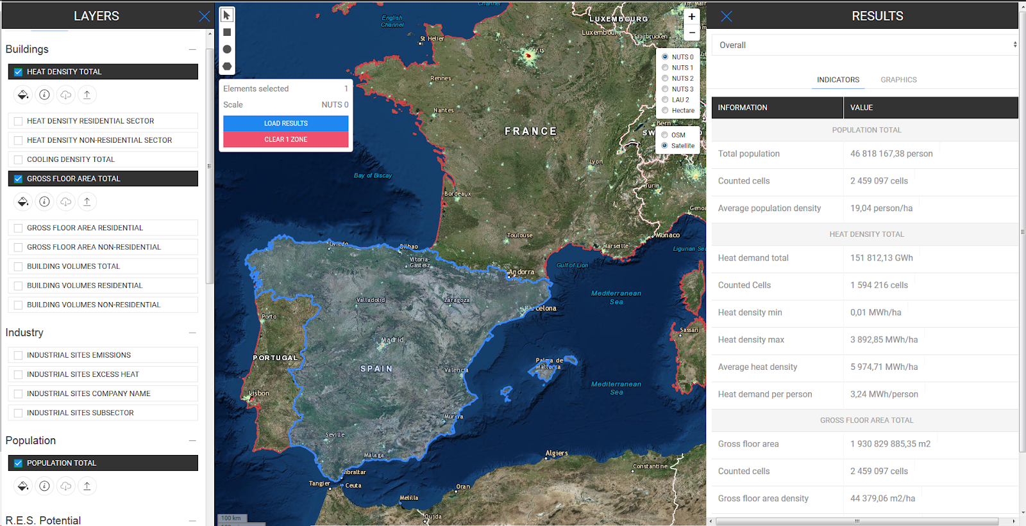

Figure : Gross floor area total map for Spain at NUTS 0 level

#### ***Show indicators at another level (NUTS 3)***

Show one or more of the other level of granularity (NUTS 1-3, LAU 2, or hectare), just to show what are the predefined levels of zoom available in the tool. Please be aware that the lowest level, LAU2, may take longer to load. This could be a good moment to mention that each indicator has a different minimum level of zoom, and that not all of them are defined at hectare level.

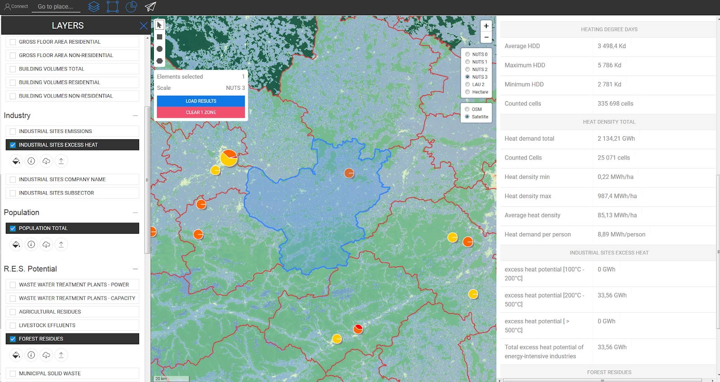

Figure : Population, potential for industrial sites excess heat and forests residues at NUTS 3 level

#### ***Select a municipality and investigate RES potentials at LAU2 or hectare level***

Pick a municipality, possibly knowing that it has some RES or industrial potential in the surroundings. Keep in mind that a custom selection allows for more flexibility than LAU2.

Select few layers to start with, such as heat demand and population, show the indicators and explain them.

Suggest relevant questions to investigate: what are potentials? Start with one, e.g. wastewater. This indicator is shown in points, so if the area selected does not include one, extend it to another cell or draw a bigger polygon that covers the plant. Industry potential is not always available in the close proximity.

Select another layer, such as forest residues. Draw a new polygon that covers some forest area and check the indicator results. You can stop here or go on with some other indicators. Just be aware that each indicator has its peculiarities, for instance solar usually yields quite large potentials, which are higher than the heat demand. This will entail to explained why that happens.

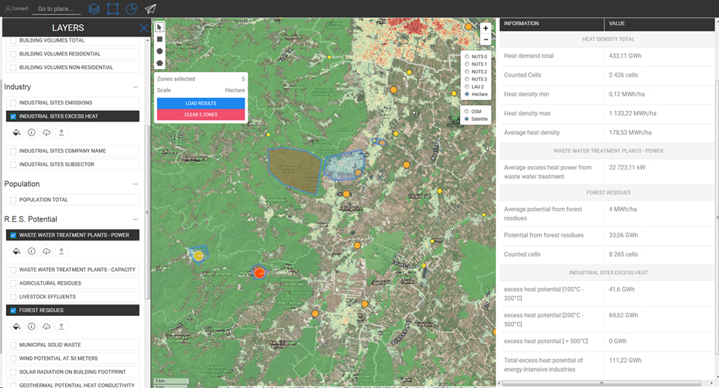

Figure : Potential for industrial sites excess heat, wastewater treatment plants power and forests residues at hectare level

#### ***Download of layers***

You can show the function of download by downloading the heat demand density map as a raster file and saving it on your computer. Just show where the ‘Download layer selection’ symbol  is located, in the side menu on the left of the screen, below every layer as can be seen in the previous figures, and click it.

Please remind participants to use one of the recommended browsers to complete this step. Issues such as not downloading any file or downloading an empty file have been reported when accessing the toolbox with other browsers.

#### ***Upload of layers and own data***

Seemingly, data can be also uploaded, which is particularly useful when using own data or a raster file previously elaborated. To show this functionality, first, unselect all the layers in the left panel. Then, log-in to your user account and then click on the ‘account’ button. Click on ‘Select files’ in the right bottom corner of the account window and proceed to your storage folder to upload your files.

The format accepted is “.tif”. Look up the file to upload from your computer using the ‘Select file’ button located at the bottom of the account window. Specify the category of data from the drop-down list to the left of the ‘Select file’ button. Make sure to select the right category of data, so if you want to re-upload the raster file that you just downloaded, select ‘Heat density total’.

Finally, click the ‘Upload layer’ button and the uploaded layer will emerge at the top of the left layer panel to be used exactly as one of the embedded layers.

Again, please remind participants to use one of the recommended browsers to complete this step. Issues such as not downloading any file or downloading an empty file have been reported when accessing the toolbox with other browsers.

#### ***Show CM – Demand Projection***

To continue, you can then show some calculation modules, explain the indicators, and show the graphs and layers. For instance, you could start with the Demand projection, which is used at the beginning of the training material (exercise 2), after the mapping exercise (exercise 1).



Figure : Calculation Module Demand Projection

#### ***Show CM – Decentral Heating Supply***

Then, you can then show the Decentral Heating supply, which is also one of the first calculation modules used in the training material (exercise 2).



Figure : Calculation Module Decentral Heating Supply

#### ***Show CM – Scale Heat and Cool Density Map***

After that, you can show the Scale Heat and Cool Density Map, and explain that when it is used in the training material. For instance, you can explain that the heat demand density layers are expressed in terms of final energy, not in terms of useful energy. In order to calculate any layer in terms of useful energy, the user can either scale every single output, multiplying them by the average efficiency factor for heating systems in the selected area, or simply use the calculation module “Scale heat and cool density map”, indicating the average efficiency factor for heating systems in the selected area, and the module will produce the heat demand density map in terms of useful energy. The map can then be downloaded, saved and used for further analysis.



Figure : Scale Heat and Cool Density Map

#### ***Show CM – District Heating supply dispatch***

At this point you could show the District Heating supply dispatch. We recommend to choose wisely the parameters and spend some time to explain the difference between the invest mode and the dispatch mode. We have noticed during the trainings, that this calculation module is perceived as more challenging, and participants were more confused about it than about other calculation modules.



Figure : Calculation Module District Heating Supply Dispatch

#### ***Show CM – District Heating potential: user defined thresholds***

The District Heating potential: user defined thresholds is another module that has proved not so easy to grasp, so you could spend some time to explain its purpose and functioning.



Figure : Calculation Module District Heating potential - user-defined thresholds

#### ***Show CM – District Heating potential: economic assessment***

Then you could move on with the District Heating potential, using the following parameters:

* Min. heat demand in hectare: 200 MWh/ha
* Min. heat demand in a DH area: 20 GWh/yr

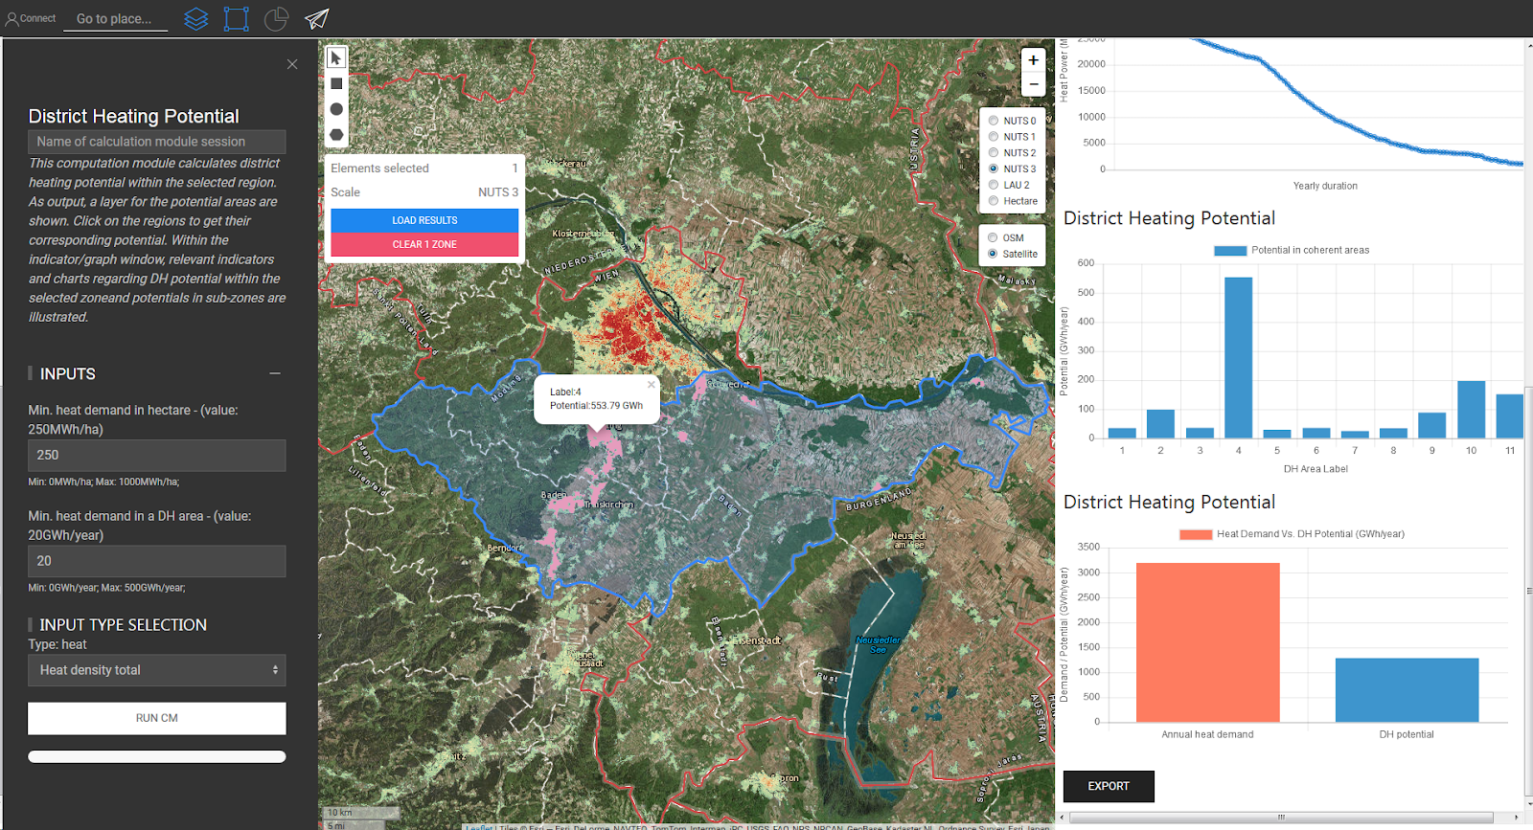

Figure : Calculation Module District Heating potential input parameters (left) and results (right)

These settings would typically result in more regions, making it easier to explain the functionality. Keep in mid that the raster file might not visible when zooming in too much. This could be a good chance to do a second run with different parameters (in which case, remember to specify a new name for the run in the inputs section of the CM), or other calculation modules.

#### ***Additional and stand-alone Calculation modules***

You can tailor the number and selection of modules to show during the live demo, based on the audience that you are addressing. One stand-alone module that is used in the training material is the Scenario Assessment (exercise 5), which consists of an Excel File. However the tool presents a number of other stand-alone modules among which to choose.



Figure : Stand-alone CM Scenario Assessment

1. Training Material

The Hotmaps follower training material was conceived originally for a series of face-to-face trainings. As previously explained, both the material and the training approach had to be adjusted after measures for containing the COVID-19 pandemic were introduced.

* 1. On-site Training

#### ***Introductory webinar (3 hours, 2 - 3 weeks before the workshop):***

A draft presentation that can be used in the introductory webinar is available under the following link: WIKI LINK TO TRAINING MATERIAL / Introductory webinar

Structure of the webinars:

* Presentation of the guidelines for strategic heating and cooling planning:
* Content:
* …
* …
* See the draft presentation.
* Presentation of the Hotmaps toolbox and dataset
* Content:
* Mapping
* scenario generation and comparison
* energy system analysis
* use of own data / import / export
* Find a live presentation guide of the tool in chapter 4 of the at hand workshop material
* Detailed explanation of …
* the workshop programme (see chapter 3 and the draft presentation)
* the preparation process (see the draft presentation)
* guiding materials (Hotmaps handbook, Hotmaps brochure, and Hotmaps tutorials; find links to all materials in the draft presentation)

#### ***Structure of the on-site training***

#### ***Explanations, exercises, feedback collection, etc.***

* 1. Online Training

This section explains what kind of materials were used during the online trainings, how they were distributed and in which order.

#### ***Introductory webinar, one week before the intensive training (1 hour)***

This webinar was meant to welcome the participants, present the trainers, the Hotmaps project, Hotmpas toolbox, the structure and modality of the training, and the e-learning platform. All webinars were provided with Microsoft Teams.

After registering for the training and receiving the welcome email with the links for the webinars, this was the first time that the participants had a chance to get in touch with the trainers.

We informed the participants that all future communications would be delivered through the e-learning platform Google Classroom. During the webinar, the first material was posted on the platform: a short tutorial presenting the Hotmaps toolbox at a glance, two introductory videos, respectively on strategic heating and cooling planning and on the Hotmaps database, and a link to the first multiple answers test, based on the content of the videos. The test was provided through Google Forms, with deadline at the end of the week. Also, the webinar’s presentation and recording were posted the same day.

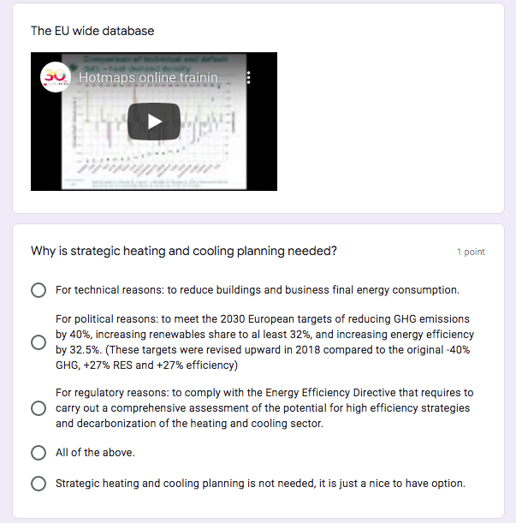

Figure : A view of the introductory quiz

The link to the Hotmaps handbooks was originally provided only in the welcome email and in the introductory webinar presentation, and then, after some participants reported that they could have used more theory around the heating and cooling planning, it was added to the introductory material.

#### ***Introduction to the use of the tool, exercises 1 - 2***

This was the first webinar of the intensive training. We assumed that the participants had accessed the material posted so far, completed the test and familiarized with the tool.

The trainers showed how to do the mapping of heat demand and resource potentials and how to calculate the decentral heat supply costs for the scenario under analysis. In order to ease the process of checking the assignments for errors, all participants were required to perform the same calculations on the same municipality: Tomaszów Mazowiecki, a large town in central Poland.

The material for exercises 1-2 was posted the night before the webinar and it included:

* A word document, with the instructions to perform the calculations,
* A spreadsheet, with the parameters to use and the space to paste the results obtained.

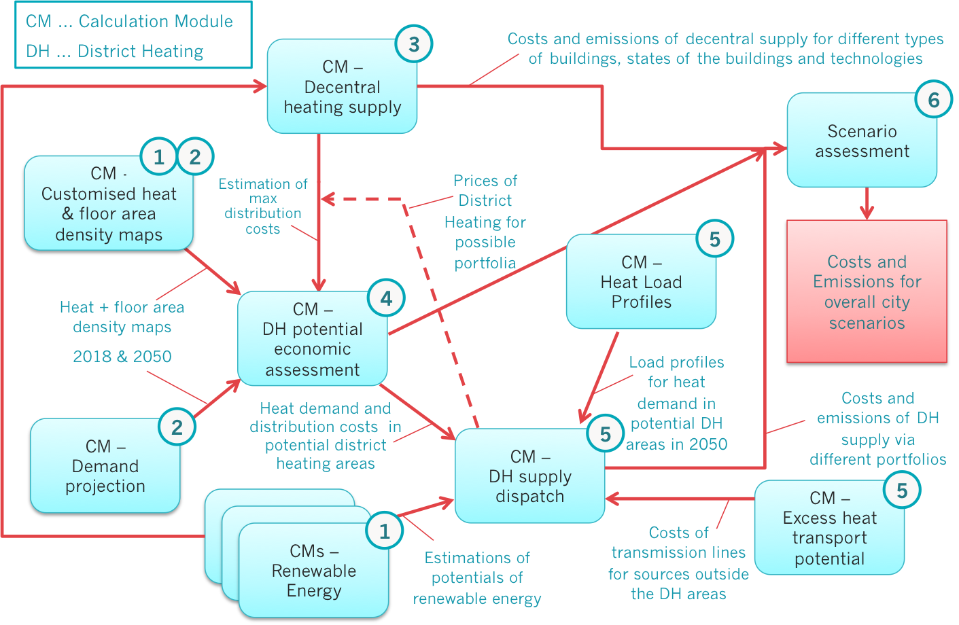

Figure : Toolchain used from exercise 1 to progressively build the scenario assessed in exercise 5

This was a good chance to remind participants to accept the email invite to join Google Classrom and to show them again how to use the e-learning platform, in case creating a Google account in case they do not have it.

As the first two exercises were distributed, the participants have been divided in groups of max 15-20 people- Each group has been assigned to one trainer, that was available during each support session to answer questions and help participants complete the exercises. The respective link to the Teams room was also distributed to each participant through the e-learning platform.

#### ***Wrap-up of exercises 1 - 2, introduction to exercises 3 and 4***

The trainers showed how exercises 1-2 were supposed to be completed and moved on showing how to calculate the district heating supply costs and distribution costs for the scenario under analysis.

The material for exercises 3-4 was posted the night before the webinar and it included, as for exercises 1-2, a word document and a spreadsheet to perform the exercise.

This was a good chance to remind participants to do good use of the support sessions.

#### ***Wrap-up of exercises 3 - 4, introduction to exercises 5***

The trainers showed how exercises 3-4 were supposed to be completed and moved on showing how to set up a consistent scenario for the region and perform the scenario assessment.

The material for exercise 5 was posted the night before the webinar and it included, as for the previous assignments, a word document and a spreadsheet to perform the exercise.

This was a good chance to remind participants of the final deadline for completing all the assignments and uploading them through the e-learning platform, as well as to inform them that in order to receive the certificate of attendance, they should have provided their full name and submitted also the feedback questionnaire.

#### ***Closing and explanation of exercises 5, feedback questionnaire, certificates and final remarks***

The trainers showed how exercise 5 was supposed to be complete and then addressed the closing of the training. An overview of the feedback received during the support session and through the feedback questionnaire was provided. Additional information was provided regarding the distribution of the certificates of attendance, which were posted on the e-learning platform at the beginning of the following week. The training certificates were provided upon completion of the training, which is to say when all assignments had been submitted. The training did not involve any evaluation of the assignments, but the correct answers of the introductory test and the completed version of exercise 5 were circulated for self-evaluation of the participants.

Because some participants asked to be able to complete the training beyond the deadline, the e-learning platform was kept open for some additional weeks in order to allow all the interested participants to complete the training and receive their certificate.

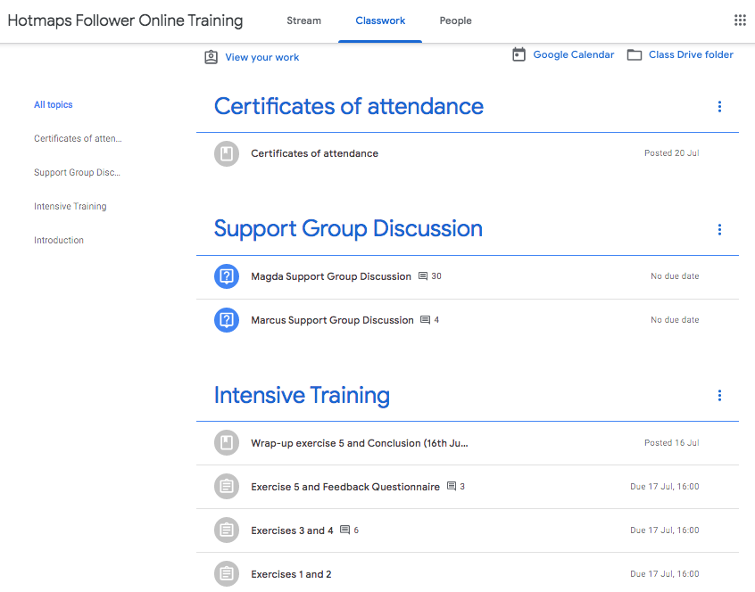

Figure : A view of the Classwork section of the e-learning platform

1. Feedback and lessons learned

Considering the research nature of the Hotmaps project, collecting feedback was particularly useful for the training team as well as for the rest of the project consortium.

* 1. On-site trainings

Evolution of the agenda, feedback received, …

* 1. Online trainings

A first round of feedback was collected in the support sessions and in the comments posted on the e-learning platform. This concerned mainly the accessibility of the Hotmaps tool, usability of the functionalities, and the bugs encountered. This was extremely useful to fix the reported bugs, but it also led to adapting the training material for subsequent trainings. Several notes have been added where relevant in order to explain those concepts that had been proved difficult to understand.

A second round of feedback was collected at the end of the online training through the feedback questionnaire that was filled out by 79 participants, of which we report below the main findings.

#### ***The tool***

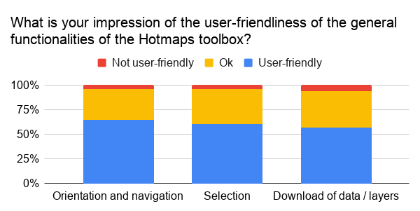

Figure : Feedback on the userfriendliness of the tool

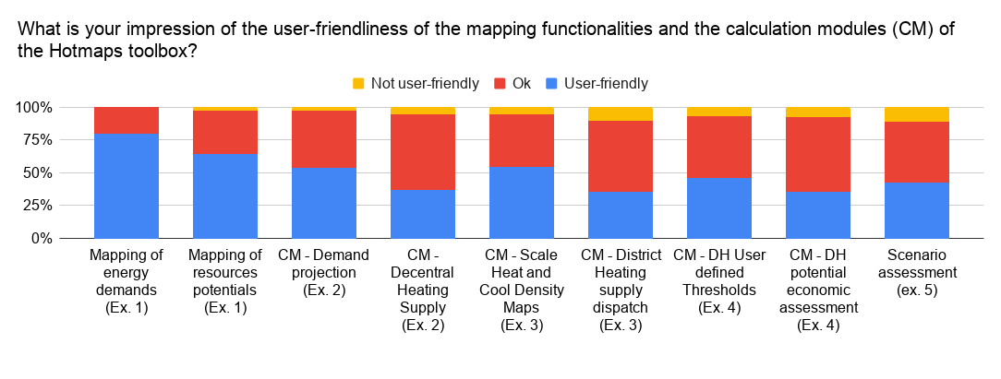

Figure : Feedback on the userfriendliness of the mapping functionalities and calculation modules

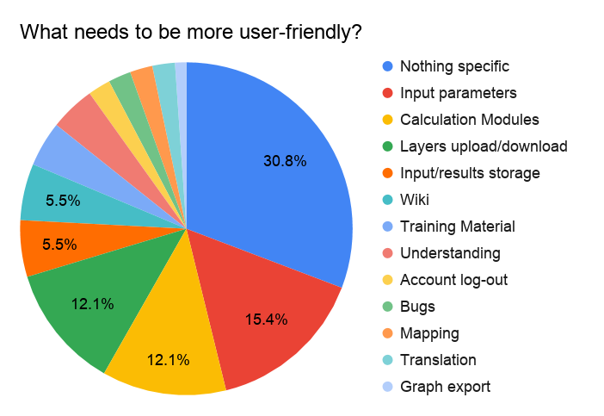

Figure : Feedback on what could be more user-friendly

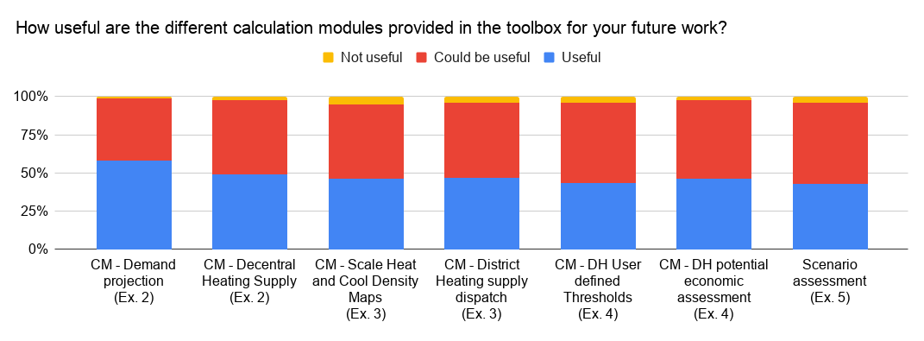

Figure : Feedback on the usefulness of the calculcation modules

Figure : Feedback on the most liked part, and expected future use of the tool

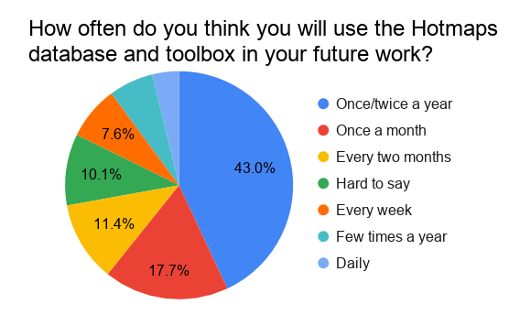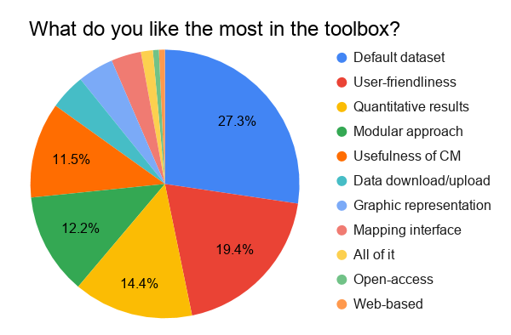

**For which activities will you use the Hotmaps database and toolbox?**

SECAP, Heat planning, and DHC project analysis

#### ***The documentation***

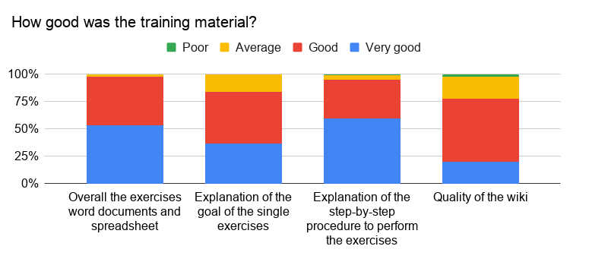

Figure : Feedback on the training material

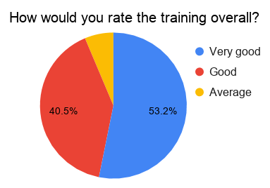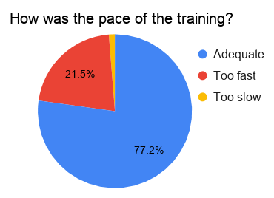

Figure : Feedback on the training quality and pace

#### ***The online training***

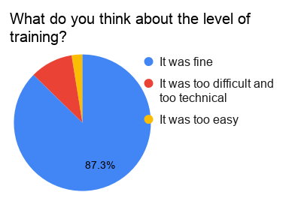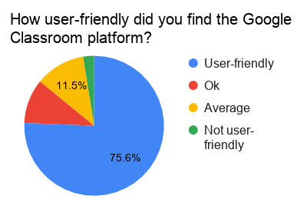

Figure : Feedback on the training level and e-learning platform

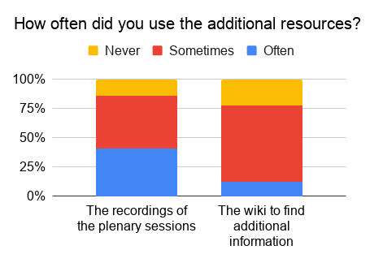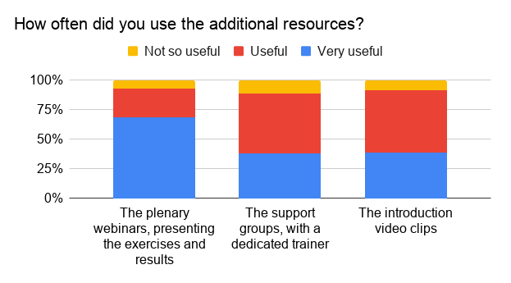

Figure : Feedback on the different parts of the training and additional resources

#### ***Participants’ suggestions***

**Level of the training** – As previously mentioned, the Hotmaps training was conceived for heating and cooling planning professionals. Accordingly, several participants had already acquired notions of heating and cooling planning theory, and could follow the training without additional preparation. Some participants would have even enjoyed more detail, additional modules, such as on District cooling and the relation to electricity and transport, as well as more structured and challenging exercises. In particular, some participants asked to better explain the definition of terms, the input and output parameters, and the purpose of each exercise, in order to achieve a deep understanding of the tool. However, some other participants, were not familiar with the subject, and decided to join the training anyway, but struggled with understanding the theory behind the Hotmaps tool and could have benefit from some preliminary study of the heating and cooling planning procedures and calculations.

**Duration of the training** – At the end of both the first two online trainings, a number of participants regretted not finding enough time to complete the training at the level of detail they would have liked, and suggested in case of future trainings, to stretch the same amount of information over a longer timespan. Consequently, the third training was spread over three weeks, but this did not produce a higher level of completion.

Other suggestions have been listed below:

* Develop more on the overall aim of Hotmaps Toolbox and its potential use on top on the mere instructions to use the tool. Focus more on the interpretation, main message and limitations of the output of the calculation modules and the exercises. Divide clearly the training material between the practice of heating and cooling planning and the Hotmaps software application.
* More team discussions, to share ideas and experiences on H&C modeling.
* Separate trainings for separate functions.
* Support sessions in different times of the day.
* Solve all the known bugs to be able to have next trainings on a stable version.
* Keep webinars and recordings short and concise, maybe splitting them in more parts.

#### ***The after-life of the Hotmaps-project***

Do you use similar tools in your daily work?

* 65% No, no specific H&C planning tool (but some use general energy assessment tools)
* Others: mainly GIS Tools (ArcGIS, Grass, QGIS, MapInfo, SAGA), BHKW-Plan, Buildup, Dymola, Ecoregion, Energieatlas Baden-Württemberg, Energy plus, HeatRoadMap Europe, Klimaschutzplaner, LEAP (Long Range Energy Alternatives Planning), Matlab, Modelica, Peta, PHPP, Polysun, PostgreSQL + PostGIS, PVSys, Retscreen, Scatter Cities, SEAI BER, Thermos, TOP Energy, Transys, as well as own spreadsheets/systems.

How much do you pay them per year?

* 60% Free
* 40% Up to 1500€/year per license, or up to 5000€.

Would you be willing to pay for a training like this?

* 30% No
* 30% Yes, up to 1000€
* 30% Depending on features/conditions: if adapted to knowledge of participants, more in depth, better preparatory training, if the final version is actually stable, if provided in other languages too

Would you pay to use this tool in the future?

* 45% No
* 50% Yes, if further developed, bugs fixed, some desired features and human support provided. (but only 44% for additional features, 30% for additional storage, 16% for faster calculations)

1. Legacy

Hotmaps is an open access database and toolbox, aiming at supporting the adoption of district heating and cooling systems in Europe. Hence, it is in the interest of the project to train as many followers as possible. Since the project is approaching its conclusion, a Training Material section has been set up in the Hotmaps Wiki. This section will remain available after the end of the project to all those users interested in either doing a self-taught and self-paced training or in organising future Hotmaps trainings. In fact, all the material has been developed with a train-the-trainer approach.

The Training Material page of the Wiki is structured as follows:

Insert menu tree of the section when ready, with links to all the materials posted (presentations, videos, exercises, test, questionnaire, certificate template)

Insert picture of the section with menu when ready

1. Annex

On-site trainings: list of participants

**Bolzano:**

|  |  |  |  |
| --- | --- | --- | --- |
| **ID** | **Vorname** | **Nachname** | **Type of organisation** |
| 1 | Ahmed | Abouaiana | Research and academics |
| 2 | Luigi | Acquaviva | Local or regional energy agencies |
| 3 | Roberto | Barella | Research and academics |
| 4 | Selva | Calixto | Research and academics |
| 5 | Sebastiano | Dal Farra | Research and academics |
| 6 | Matthias | Haase | Consultancy companies |
| 7 | Janka | Lengyel | Research and academics |
| 8 | Per Sieverts | Nielsen | Research and academics |
| 9 | Pedro | Palma | Research and academics |
| 10 | Eleonora | Simonini | Local or regional public authorities |
| 11 | Burcu | Unluturk | Research and academics |

**Brussels:**

|  |  |  |  |
| --- | --- | --- | --- |
| **ID** | **Vorname** | **Nachname** | **Type of organisation** |
| 1 | Gabriella | Abate | Local or regional energy agencies |
| 2 | Santo | Abate | Local or regional energy agencies |
| 3 | Laùrah | Ahamadi | Local or regional public authorities |
| 4 | Josip | Beber | Other |
| 5 | Wahib | Belaribi | Local or regional public authorities |
| 6 | Jacqui | Cullen | Local or regional public authorities |
| 7 | Christodoulos | Ellinopoulos | Other public organisations (public agencies, national authorities...) |
| 8 | Pierre | Germain | Local or regional public authorities |
| 9 | Rogério | Ivan | Local or regional energy agencies |
| 10 | Anna | Jaskula | Local or regional energy agencies |
| 11 | Joseph | Jebamalai | Consultancy companies |
| 12 | Nuri Cihan | Kayaçetin | Other public organisations (public agencies, national authorities...) |
| 13 | Eric | Kenda | Local or regional energy agencies |
| 14 | Tilen | Kosi | Consultancy companies |
| 15 | Yixiao | Ma | Research and academics |
| 16 | Kurt | Marlein | Consultancy companies |
| 17 | Vitaly | Matveev | Other public organisations (public agencies, national authorities...) |
| 18 | Panayiotis | Michael | Local or regional public authorities |
| 19 | Charlotte | Petit | Local or regional public authorities |
| 20 | Stefan | Petrovic | Research and academics |
| 21 | Patrycja | Płonka | Local or regional energy agencies |
| 22 | Katarina | Pogacnik | Consultancy companies |

Online trainings: list of participants

**First English Online Training:**

|  |  |  |  |
| --- | --- | --- | --- |
| **Id** | **Vorname** | **Nachname** | **Type Of Organisation** |
| 1 | Amani | Alabdullah | Local Or Regional Public Authorities |
| 2 | Faig | Alishanov | Local Or Regional Public Authorities |
| 3 | Juan | Alvarez | Local Or Regional Energy Agencies |
| 4 | Annalaura | Antonelli | Local Or Regional Public Authorities |
| 5 | Meglena | Antonova | Local Or Regional Public Authorities |
| 6 | Adrian Cristian | Astalis | Local Or Regional Public Authorities |
| 7 | Michela | Aufiero | Local Or Regional Public Authorities |
| 8 | Jessica | Balest | Local Or Regional Public Authorities |
| 9 | Christine | Ballard | Local Or Regional Public Authorities |
| 10 | Gian | Beratto | Local Or Regional Public Authorities |
| 11 | Sara | Biscaia | Local Or Regional Public Authorities |
| 12 | Mentenanta | Bistrita | Research And Academics |
| 13 | Mark | Bramah | Research And Academics |
| 14 | Darren | Burke | Consultancy Companies |
| 15 | Luca | Casamassima | Research And Academics |
| 16 | Alessandro | Cavalli | Research And Academics |
| 17 | Bestar | Cekrezi | Other |
| 18 | Constantinos | Constantinou | Research And Academics |
| 19 | Gianmarco | Curti | Consultancy Companies |
| 20 | Gerard | Doherty | Consultancy Companies |
| 21 | Silvia | Domingo | Consultancy Companies |
| 22 | Jeremy | Draper | Local Or Regional Energy Agencies |
| 23 | Monika | Duricova | Consultancy Companies |
| 24 | Gareth | Ellis | Other Public Organisations (Public Agencies, National Authorities...) |
| 25 | Essam | Elnagar | Consultancy Companies |
| 26 | Xabier | Esteban | Consultancy Companies |
| 27 | Barbara | Fanetti | Research And Academics |
| 28 | Chris | Forster | Research And Academics |
| 29 | Samuele | Fortina | Consultancy Companies |
| 30 | Arantxa | García | Research And Academics |
| 31 | Jon | Gastañares | Local Or Regional Energy Agencies |
| 32 | Essi | Geraldo | Consultancy Companies |
| 33 | Volodymyr | Halaniuk | Consultancy Companies |
| 34 | Benjamin | Hickman | Consultancy Companies |
| 35 | Bernard | Istasse | Local Or Regional Public Authorities |
| 36 | Philip | James | Local Or Regional Public Authorities |
| 37 | Juraj | Kerestúr | Ngos / Associations |
| 38 | Valeria | Khnykina | Consultancy Companies |
| 39 | Andrew | Kirwan | Local Or Regional Public Authorities |
| 40 | Arijan | Krapic | Other |
| 41 | Igor | Krupenski | Local Or Regional Public Authorities |
| 42 | Chandra | Kumar | Consultancy Companies |
| 43 | Oksana | Kysil | Local Or Regional Public Authorities |
| 44 | Giacomo | Lauritano | Local Or Regional Public Authorities |
| 45 | Barbora | Maleckova | Consultancy Companies |
| 46 | Sumanth | Manthapuri | Research And Academics |
| 47 | Altin | Maraj | Consultancy Companies |
| 48 | Iker | Mardaras | Other |
| 49 | Iker | Martinez | Consultancy Companies |
| 50 | Ciaran | Mcgrath | Research And Academics |
| 51 | Sofia | Mendonça | Consultancy Companies |
| 52 | Nicole | Molinaro | Local Or Regional Public Authorities |
| 53 | Andrei | Morari | Local Or Regional Public Authorities |
| 54 | Jane | Neylan | Consultancy Companies |
| 55 | Rafael | Otegi | Other |
| 56 | Ioan | Papoi | Research And Academics |
| 57 | Max | Peters | Other |
| 58 | Liam | Scott | Other |
| 59 | Mic | Simona | Local Or Regional Public Authorities |
| 60 | Maria | Skenter | Other Public Organisations (Public Agencies, National Authorities...) |
| 61 | Matus | Skvarka | Local Or Regional Energy Agencies |
| 62 | Heather | Stevenson | Ngos / Associations |
| 63 | Michael | Suddens | Local Or Regional Public Authorities |
| 64 | Domen | Svetlin | Local Or Regional Public Authorities |
| 65 | Kremena | Todorova Pavlova | Local Or Regional Public Authorities |
| 66 | Aljoša | Umek | Other |
| 67 | Tetyana | Varenko | Research And Academics |
| 68 | Luís Miguel | Vitorino Martins | Other |
| 69 | Drew | Walker | Research And Academics |
| 70 | Eric | Wilczynski | Research And Academics |
| 71 | Chiara Maria | Wolter | Ngos / Associations |
| 72 | Владимир | Галанюк | Other Public Organisations (Public Agencies, National Authorities...) |
| 73 | Юлія | Перчук | Other Public Organisations (Public Agencies, National Authorities...) |

**First German Online Training:**

|  |  |  |  |
| --- | --- | --- | --- |
| **ID** | **Vorname** | **Nachname** | **Type of organisation** |
| 1 | Ali | Aydemir | Research and academia |
| 2 | Jimmy | Barco Burgos | Research and academia |
| 3 | Helmut | Böhnisch | Local/regional public authorities |
| 4 | Britta | Borger | Research and academia |
| 5 | Michael | Broydo | Utilities |
| 6 | Monika | Brudler | Local/regional public authorities |
| 7 | Britta | Borger | Local/regional public authorities |
| 8 | Toni | Dingl | Local/regional public authorities |
| 9 | Nele | Dreisbach | Consultancy |
| 10 | Daniel | Dreke | Local/regional public authorities |
| 11 | Laura | Düpre | NGOs / Association |
| 12 | AGFW | Energieeffizienzverband | Utility |
| 13 | Matthias | Ertmer | Local/regional public authorities |
| 14 | Paul | Fay |  |
| 15 | FliFla | Flosse | Utilities |
| 16 | Werner | Franek | Research and academia |
| 17 | Markus | Fritz | Local/regional public authorities |
| 18 | Karin | Gerhardt | Research and academia |
| 19 | Prabhat | Hegde | Local/regional public authorities |
| 20 | Herbert | Hemis | Local/regional energy agencies |
| 21 | Stefan | Heyde | Research and academia |
| 22 | Michael | Hörner | Local/regional public authorities |
| 23 | Roman | Igelspacher | Utility |
| 24 | Rimma | Koganskaya | Research and academia |
| 25 | Heidrun | Kögler | Local/regional energy agencies |
| 26 | Christopher | Lüning | Local/regional energy agencies |
| 27 | Barbora | Maleckova | Consultancy |
| 28 | Altin | Maraj | Research and academia |
| 29 | Anika | May | Local/regional public authorities |
| 30 | Paula | Möhring | Research and academia |
| 31 | Paula | Niehues | Research and academia |
| 32 | Eftim | Popovski | Research and academia |
| 33 | Gerd | Prohaska | Local/regional public authorities |
| 34 | Georg | Reinhardt | Local/regional public authorities |
| 35 | Andreas | Repper | Local/regional public authorities |
| 36 | Ulrich | Rochard | Consultancy |
| 37 | Christoph | Runst | Local/regional public authorities |
| 38 | Ruben | Schauer | Local/regional public authorities |
| 39 | Elisabeth | Schütze | Local/regional public authorities |
| 40 | Joanna | Skok | Local/regional energy agencies |
| 41 | Oliver | Spielhaupter | Consultancy |
| 42 | Mirjam | Stappel | Research and academia |
| 43 | Thomas | Steidle | Local/regional energy agencies |
| 44 | Aneta | Strzalka | Business |
| 45 | Niko | Themeßl | Research and academia |
| 46 | Fabian | Wagenbach | Other |
| 47 | Nora | Zentner | Local/regional public authorities |

**Second English Online Training:**

|  |  |  |  |
| --- | --- | --- | --- |
| **ID** | **Vorname** | **Nachname** | **Type of organisation** |
| 1 | David | Kammerhofer | Local or regional energy agencies |
| 2 | John | Collins | Local or regional public authorities |
| 3 | Jonathan | Fronhoffs | Consultancy companies |
| 4 | Samuele | Giacometti | Local or regional energy agencies |
| 5 | Sergio | Gollino | Local or regional energy agencies |
| 6 | Matteo | Mazzolini | Local or regional energy agencies |
| 7 | Giulia | Pederiva | Local or regional energy agencies |
| 8 | Iva | Tustanovski | Local or regional energy agencies |
| 9 | Daniele | Barbieri | Local or regional energy agencies |
| 10 | Christian | Sakulin | Local or regional energy agencies |
| 11 | Johanna | Eichermüller | NGOs / Associations |
| 12 | Evan | Willemsen | Consultancy companies |
| 13 | Michel | Dau | Consultancy companies |
| 14 | Dimitris | Karamitsos | NGOs / Associations |
| 15 | Heidrun | Kögler | Local or regional energy agencies |
| 16 | Valentin | Schalk | Consultancy companies |
| 17 | Maurizio | Cremi | Consultancy companies |
| 18 | Ahmed | Abouaiana | Research and academics |
| 19 | Altin | Maraj | Research and academics |
| 20 | Aneta | Strzalka | Research and academics |
| 21 | Christoph | Obst | Business |
| 22 | Markus | Biberachert | Research and academics |
| 23 | Lukas | Götzlich | Research and academics |
| 24 | Semen | Pavlenko | Consultancy companies |
| 25 | Patrick | Geiger | Research and academics |
| 26 | Herbert | Hemis | Local or regional public authorities |
| 27 | Josip | Beber | Business |
| 28 | Patricia | Cameselle | Other |
| 29 | Bratislav | Djordjevic | Local or regional public authorities |
| 30 | Michel | Schnitz | Research and academics | NGOs / Associations |
| 31 | Matjaz | Kobal | Consultancy companies |
| 32 | Peter | Ahcin | Consultancy companies |
| 33 | Kata | Györi | Research and academics | NGOs / Associations |
| 34 | Csaba | Csontos | NGOs / Associations |
| 35 | László | Magyar | NGOs / Associations |
| 36 | Georg | Reinhardt | Local or regional public authorities |
| 37 | Giulia | Conforto | Research and academics | NGOs / Associations |
| 38 | Sebastian | Forthuber | Research and academics | NGOs / Associations |
| 39 | Lucienne | Scicluna | Consultancy companies |
| 40 | Markus | Fritz | Research and academics |